EXP NO: 9 | Basic Calculator App Using Android UI Controls

AIM:
Develop an Android application using controls like Button, TextView, EditText for designing a calculator having basic functionality like Addition, Subtraction, multiplication, and Division.

CODE:
MainActivity.kt package com.example.myapplication_karthick_79

import android.os.Bundle import android.view.View import android.widget.Button import android.widget.EditText import android.widget.Toast import androidx.appcompat.app.AppCompatActivity

class MainActivity : AppCompatActivity() {

private lateinit var display: EditText private var currentInput: String = "" private var operand1: Double = 0.0 private var operand2: Double = 0.0
private var operator: String = ""

override fun onCreate(savedInstanceState: Bundle?) { super.onCreate(savedInstanceState)
setContentView(R.layout.activity_main)

display = findViewById(R.id.display)

// Number buttons setButtonClickListener(R.id.button0) setButtonClickListener(R.id.button1) setButtonClickListener(R.id.button2) setButtonClickListener(R.id.button3) setButtonClickListener(R.id.button4) setButtonClickListener(R.id.button5) setButtonClickListener(R.id.button6) setButtonClickListener(R.id.button7) setButtonClickListener(R.id.button8) setButtonClickListener(R.id.button9)

// Operator buttons
setOperatorClickListener(R.id.buttonAdd, "+") setOperatorClickListener(R.id.buttonSubtract, "-") setOperatorClickListener(R.id.buttonMultiply, "*") setOperatorClickListener(R.id.buttonDivide, "/")

// Clear button
findViewById<Button>(R.id.buttonClear).setOnClickListener { currentInput = "" operand1 = 0.0 operand2 = 0.0 operator = ""
display.setText("")
}

// Equal button
findViewById<Button>(R.id.buttonEqual).setOnClickListener { if (operator.isEmpty()) return@setOnClickListener
try {
operand2 = currentInput.toDouble()

val result = when (operator) { "+" -> operand1 + operand2
"-" -> operand1 - operand2
"*" -> operand1 * operand2
"/" -> {
if (operand2 == 0.0) {
Toast.makeText(this@MainActivity, "Cannot divide by zero",
Toast.LENGTH_SHORT).show()
return@setOnClickListener
}
operand1 / operand2
} else -> 0.0
}

display.setText(result.toString()) operand1 = result // Update operand1 for subsequent calculations operator = "" currentInput = result.toString()
} catch (e: Exception) {
Toast.makeText(this@MainActivity, "Error: Invalid Input",
Toast.LENGTH_SHORT).show()
}
}
}

// Set up number button listeners private fun setButtonClickListener(buttonId: Int) { val button: Button = findViewById(buttonId) button.setOnClickListener { currentInput += button.text.toString()
display.setText(currentInput)
}
}

// Set up operator button listeners
private fun setOperatorClickListener(buttonId: Int, op: String) { val button: Button = findViewById(buttonId) button.setOnClickListener { if (currentInput.isNotEmpty()) { operand1 = currentInput.toDouble()
currentInput = ""
operator = op
}
}
}

// Optional: Add functionality to handle decimal point (if needed) private fun isDecimalPointValid(): Boolean {
return !currentInput.contains(".")
}

}

activity_main.xml
<?xml version="1.0" encoding="utf-8"?>
<LinearLayout xmlns:android="http://schemas.android.com/apk/res/android" xmlns:tools="http://schemas.android.com/tools" android:id="@+id/calculatorLayout" android:layout_width="match_parent" android:layout_height="match_parent" android:orientation="vertical" android:padding="16dp"
tools:context=".MainActivity">

<EditText
android:id="@+id/display" android:layout_width="match_parent" android:layout_height="80dp" android:background="#000000" android:textColor="#FFFFFF" android:textSize="28sp" android:gravity="end|center_vertical" android:inputType="none" android:focusable="false" android:clickable="false" android:padding="12dp" android:layout_marginBottom="12dp" />

<!-- Row 1: 7 8 9 / --> <LinearLayout android:layout_width="match_parent" android:layout_height="wrap_content" android:orientation="horizontal">
<Button android:id="@+id/button7" style="@style/CalcButton" android:text="7" />
<Button android:id="@+id/button8" style="@style/CalcButton" android:text="8" />
<Button android:id="@+id/button9" style="@style/CalcButton" android:text="9" />
<Button android:id="@+id/buttonDivide" style="@style/CalcButton" android:text="/" /> </LinearLayout>

<!-- Row 2: 4 5 6 * -->
<LinearLayout
android:layout_width="match_parent" android:layout_height="wrap_content" android:orientation="horizontal">
<Button android:id="@+id/button4" style="@style/CalcButton" android:text="4" />
<Button android:id="@+id/button5" style="@style/CalcButton" android:text="5" />
<Button android:id="@+id/button6" style="@style/CalcButton" android:text="6" />
<Button android:id="@+id/buttonMultiply" style="@style/CalcButton" android:text="*" />
</LinearLayout>

<!-- Row 3: 1 2 3 - --> <LinearLayout android:layout_width="match_parent" android:layout_height="wrap_content" android:orientation="horizontal">
<Button android:id="@+id/button1" style="@style/CalcButton" android:text="1" />
<Button android:id="@+id/button2" style="@style/CalcButton" android:text="2" />
<Button android:id="@+id/button3" style="@style/CalcButton" android:text="3" />
<Button android:id="@+id/buttonSubtract" style="@style/CalcButton" android:text="-" /> </LinearLayout>

<!-- Row 4: 0 C = + --> <LinearLayout android:layout_width="match_parent" android:layout_height="wrap_content" android:orientation="horizontal">
<Button android:id="@+id/button0" style="@style/CalcButton" android:text="0" />
<Button android:id="@+id/buttonClear" style="@style/CalcButton" android:text="C" />
<Button android:id="@+id/buttonEqual" style="@style/CalcButton" android:text="=" />
<Button android:id="@+id/buttonAdd" style="@style/CalcButton" android:text="+" /> </LinearLayout>

</LinearLayout>

styles.xml <resources>
<style name="CalcButton">
<item name="android:layout_width">0dp</item>
<item name="android:layout_height">wrap_content</item>
<item name="android:layout_weight">1</item>
<item name="android:padding">16dp</item>
<item name="android:textSize">24sp</item>
<item name="android:background">?attr/selectableItemBackground</item>
<item name="android:textColor">#000000</item>
</style>
</resources>

OUTPUT:
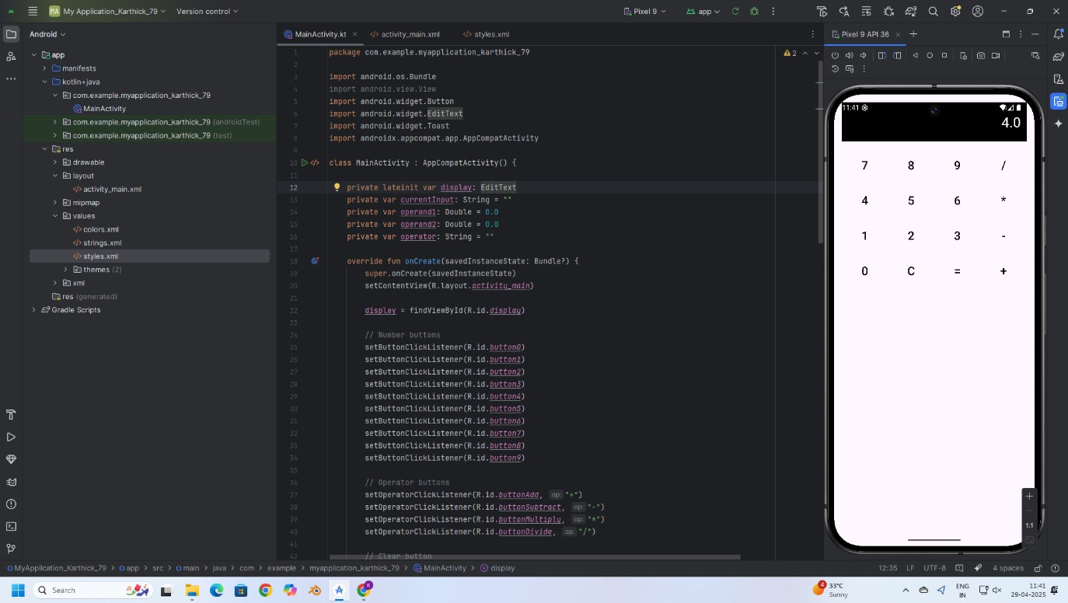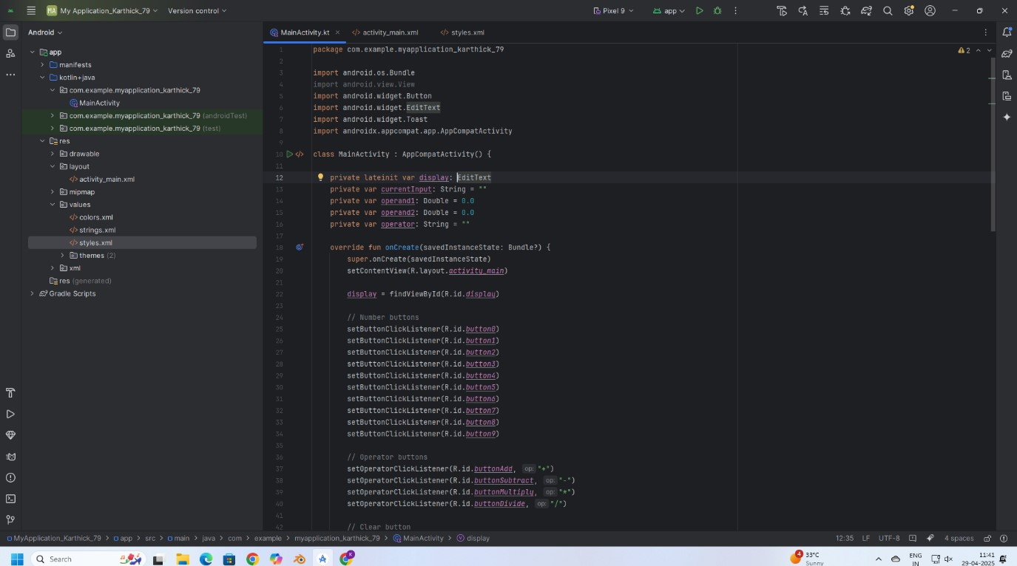
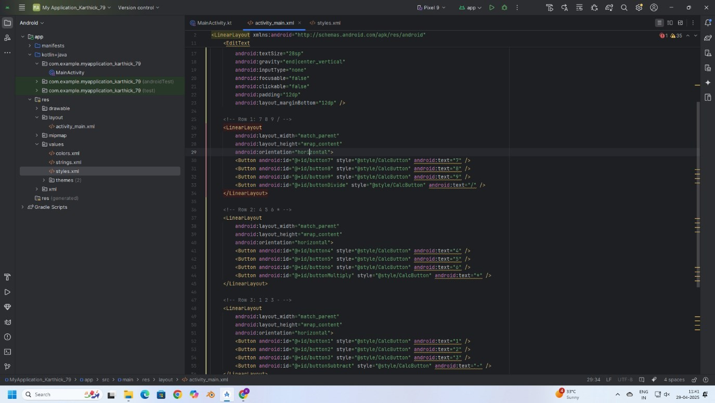
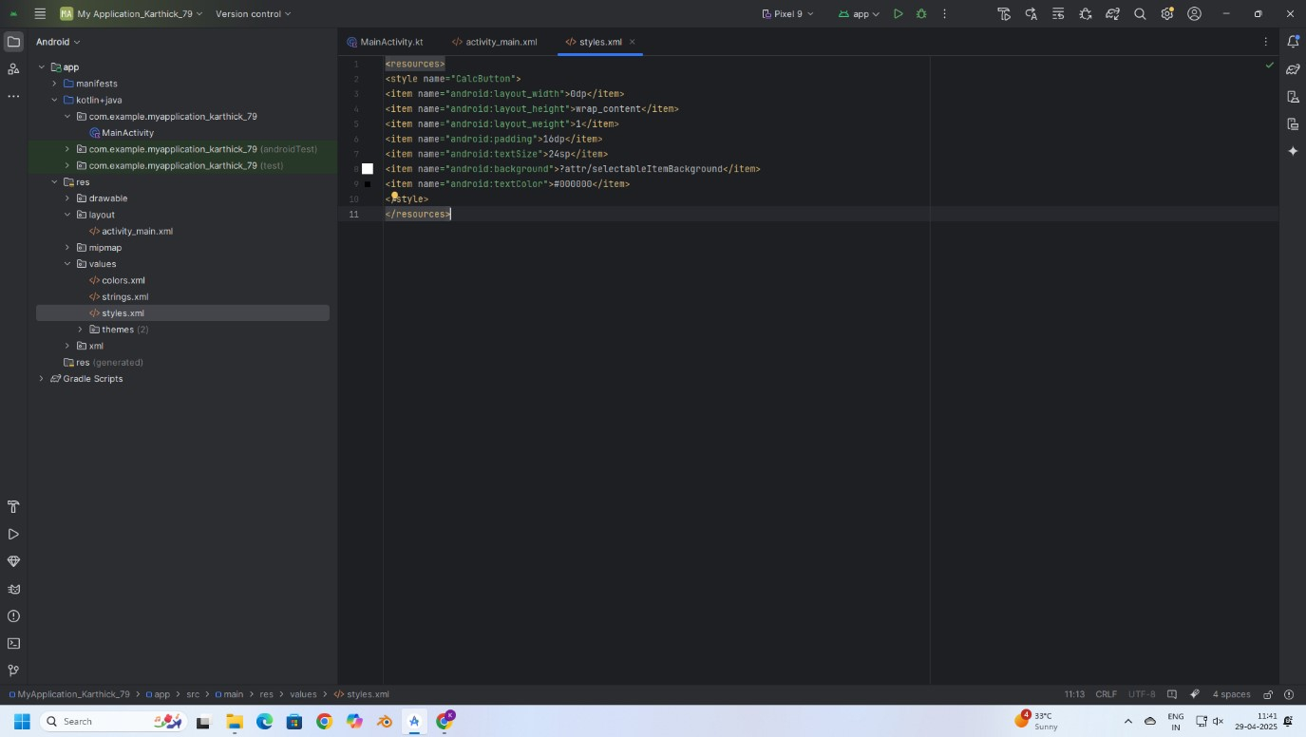
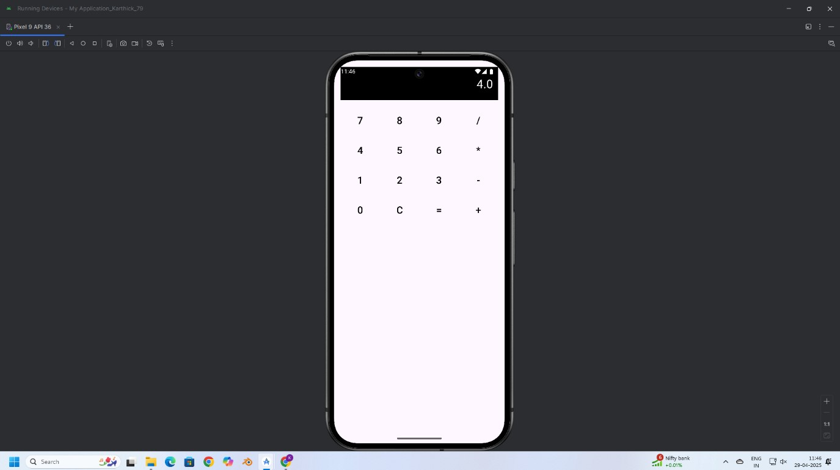

RESULT:
Thus, a basic calculator application was successfully developed using Android controls like Button, TextView, and EditText to perform addition, subtraction, multiplication, and division operations.

